**Task (3): HTML Questions**

1. **Can We Put Form Inside a Form (Can we Create a “Nested Form” in HTML)?**

Nested Forms means placing one <form> element inside another.

In HTML it’s not allowed because it can lead to unexpected behavior and conflicts between forms and web browsers do not support nested forms.

However, it can be done in two approaches:

1. **Independent Forms:**

In this approach each form should be placed outside the scope of any other form.

It assures that each form functions correctly and submit its data independently.

* Example:

<!DOCTYPE html>

<**html**>

<**head**>

     <**title**>Nested Forms</**title**>

</**head**>

   <**body**>

      <**h3**>Nesting forms</**h3**>

1st Form (1):

     <**p**> <**b**>Form 1:</**b**> </**p**>

     <**form** id="form1" action="/submitForm1">

         <**label** for="name">Name:</**label**>

         <**input** type="text" id="name" name="name" required><**br**>

<**label** for="email"> Email: </**label**>

        <**input** type="email" id="email" name="email" required><**br**>

         <**input** type="submit" value="Submit Form 1">

    </**form**>

Now Form 2:

<**br**>

    <**p**> <**b**>Form 2:</**b**></**p**>

<**form** id="form2" action="/submitForm2">

<**label** for="message">Message:</**label**><**br>** <**textarea**id="message"name="message"rows="4"cols="50"required>

</**textarea**>

<**br**>

<**input** type="submit" value="Submit Form 2">

   </**form**>

</**body**>

  </**html**>

Output:

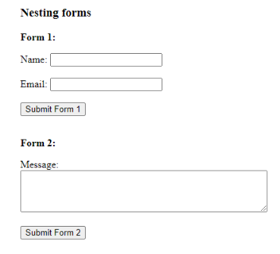

1. **Sectional Divisions:**

If you require logical divisions within a single form, you can use HTML elements such as [**<fieldset>**](https://www.geeksforgeeks.org/html5-fieldset-tag/)or [**<div>**](https://www.geeksforgeeks.org/div-tag-html/)to group related inputs together. Although these divisions visually appear as separate sections, they are still part of the same form.

These sections provide a visual grouping of related inputs within the same form, but they are not separate forms. When the submit button is clicked, the entire form, including all sections, will be submitted together.

* Example:

<!DOCTYPE html>

<**html**>

<**head**>

<**title**>Sectional Nested Form</**title**>

</**head**>

<**body**>

    <**form** id="mainForm" action="/submitMainForm">

    <**label** for="name"> Name:</**label**>

    <**input** type="text"id="name"name="name" required><**br**>

    <**label** for="email">Email:</**label**>

    <**input** type="email" id="email" name="email" required><**br**>

<**fieldset**>

    <**legend**>Section 1</**legend**>

       <!-- Section 1 fields -->

    <**label** for="age">Age:</**label**>

    <**input** type="number"id="age" name="age" required><**br**>

    <**label** for="gender">Gender:</**label**>

    <**select** id="gender"name="gender" required>

    <**option** value="">Select</**option**>

    <**option** value="male">Male</**option**>

    <**option** value="female">Female</**option**>

    <**option** value="other">Other</**option**>

    </**select**><**br**><**br**>

    </**fieldset**>

    <**fieldset**>

    <**legend**>Section 2</**legend**>

       <!-- Section 2 fields -->

<**label** for="message">Message:</**label**>

    <**textarea** id="message"name="message"rows="4"cols="50" required>

    </**textarea**><**br**>

    <**label** for="rating">Rating:</**label**>

    <**input** type="number id="rating" name="rating" min="1 max="5" required><**br**>

    </**fieldset**>

        <**br**>

    <**button** type="submit">Submit</**button**>

    </**form**>

</**body**>

</**html**>

Output:

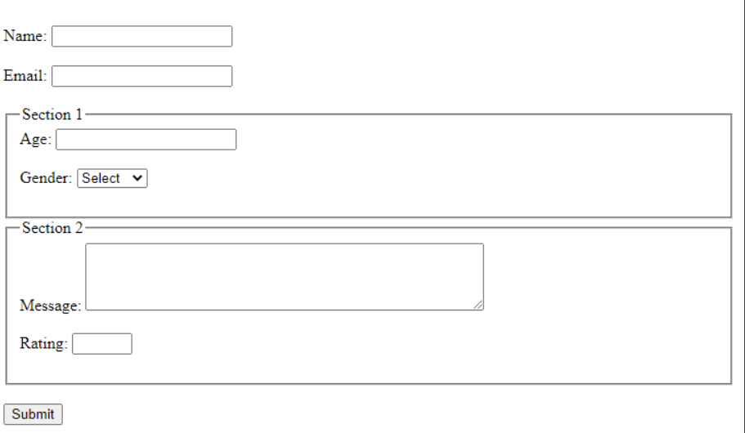

1. **What happens if there is more than one Input type submit?**

It’s valid to have more than one submit button in a single form. Each button submits the form to a different URL using the formaction attribute, allowing users to perform different actions based on which button they click.

The formaction attribute overrides the action attribute of the form and send data to desired location.

* Example:

<<button type="submit" formaction="https://www.geeksforgeeks.org/"

                name="submit_type" value="submit_1">

            Hello

        </button>

        <!-- Submit Button 2 -->

        <button type="submit" formaction="https://www.geeksforgeeks.org/about/"

                name="submit_type" value="submit_2">

            Submit 2

        </button>

1. **If there is no Submit Button, who can we submit a form?**

**1. Using JavaScript to Submit on Input Change**

You can use JavaScript to automatically submit the form when a certain input changes.

* Example:

  <script>

        function autoSubmit() {

            document.getElementById("myForm").submit();

        }

    </script>

</head>

<body>

    <form id="myForm" action="/submit" method="POST">

        <label for="name">Name:</label>

        <input type="text" id="name" name="name" oninput="autoSubmit()" required>

        <label for="email">Email:</label>

        <input type="email" id="email" name="email" oninput="autoSubmit()" required>

    </form>

**2. Using a Button with JavaScript Event**

Instead of a traditional submit button, you can use a regular button styled as needed and attach a JavaScript function to handle the submission.

* Example:

  <script>

        function submitForm() {

            document.getElementById("myForm").submit();

        }

    </script>

</head>

<body>

    <form id="myForm" action="/submit" method="POST">

        <label for="name">Name:</label>

        <input type="text" id="name" name="name" required>

        <label for="email">Email:</label>

        <input type="email" id="email" name="email" required>

        <button type="button" onclick="submitForm()">Send</button> <!-- Not a traditional submit button -->

    </form>

</body>

**3.Using a Timer or Delay**

If you want to submit the form automatically after a certain time, you can use a timer.

* Example:

    <script>

        function autoSubmit() {

            setTimeout(() => {

                document.getElementById("myForm").submit();

            }, 5000); // Submits after 5 seconds

        }

    </script>

</head>

<body onload="autoSubmit()">

    <form id="myForm" action="/submit" method="POST">

        <label for="name">Name:</label>

        <input type="text" id="name" name="name" required>

        <label for="email">Email:</label>

        <input type="email" id="email" name="email" required>

    </form>

</body>

* Resources:

1. <https://www.tutorialspoint.com/how-can-i-use-multiple-submit-buttons-in-an-html-form>
2. <https://stackoverflow.com/questions/3430214/form-inside-a-form-is-that-alright>
3. <https://www.quora.com/How-can-you-create-a-form-that-doesnt-have-a-submit-button>
4. <https://www.geeksforgeeks.org/can-we-create-a-nested-form-in-html/>
5. <https://stackoverflow.com/questions/42010159/are-two-or-more-submit-buttons-in-single-form-valid-html>
6. <https://www.w3schools.com/>